**VPC:**

* Create two VPC’s ,two public subnets,two private subnets,two nat gateways,two internet gateways.
* Create the one more public subnet for bastion host.

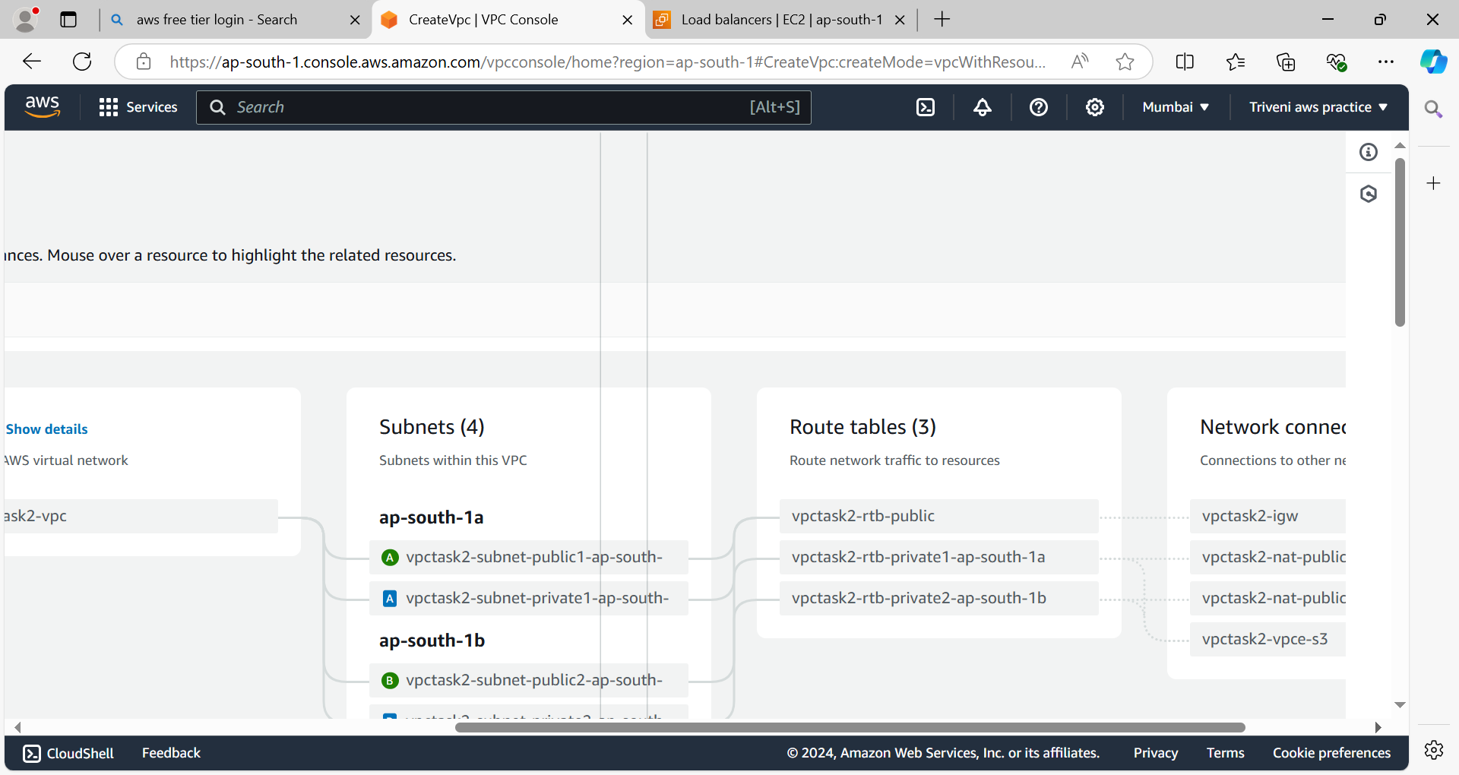

**Autoscaling Group:**

* Before creating the autoscaling group we have to create launch template.
* Create the autoscaling group while creating autoscaling group we need to select private subnets.

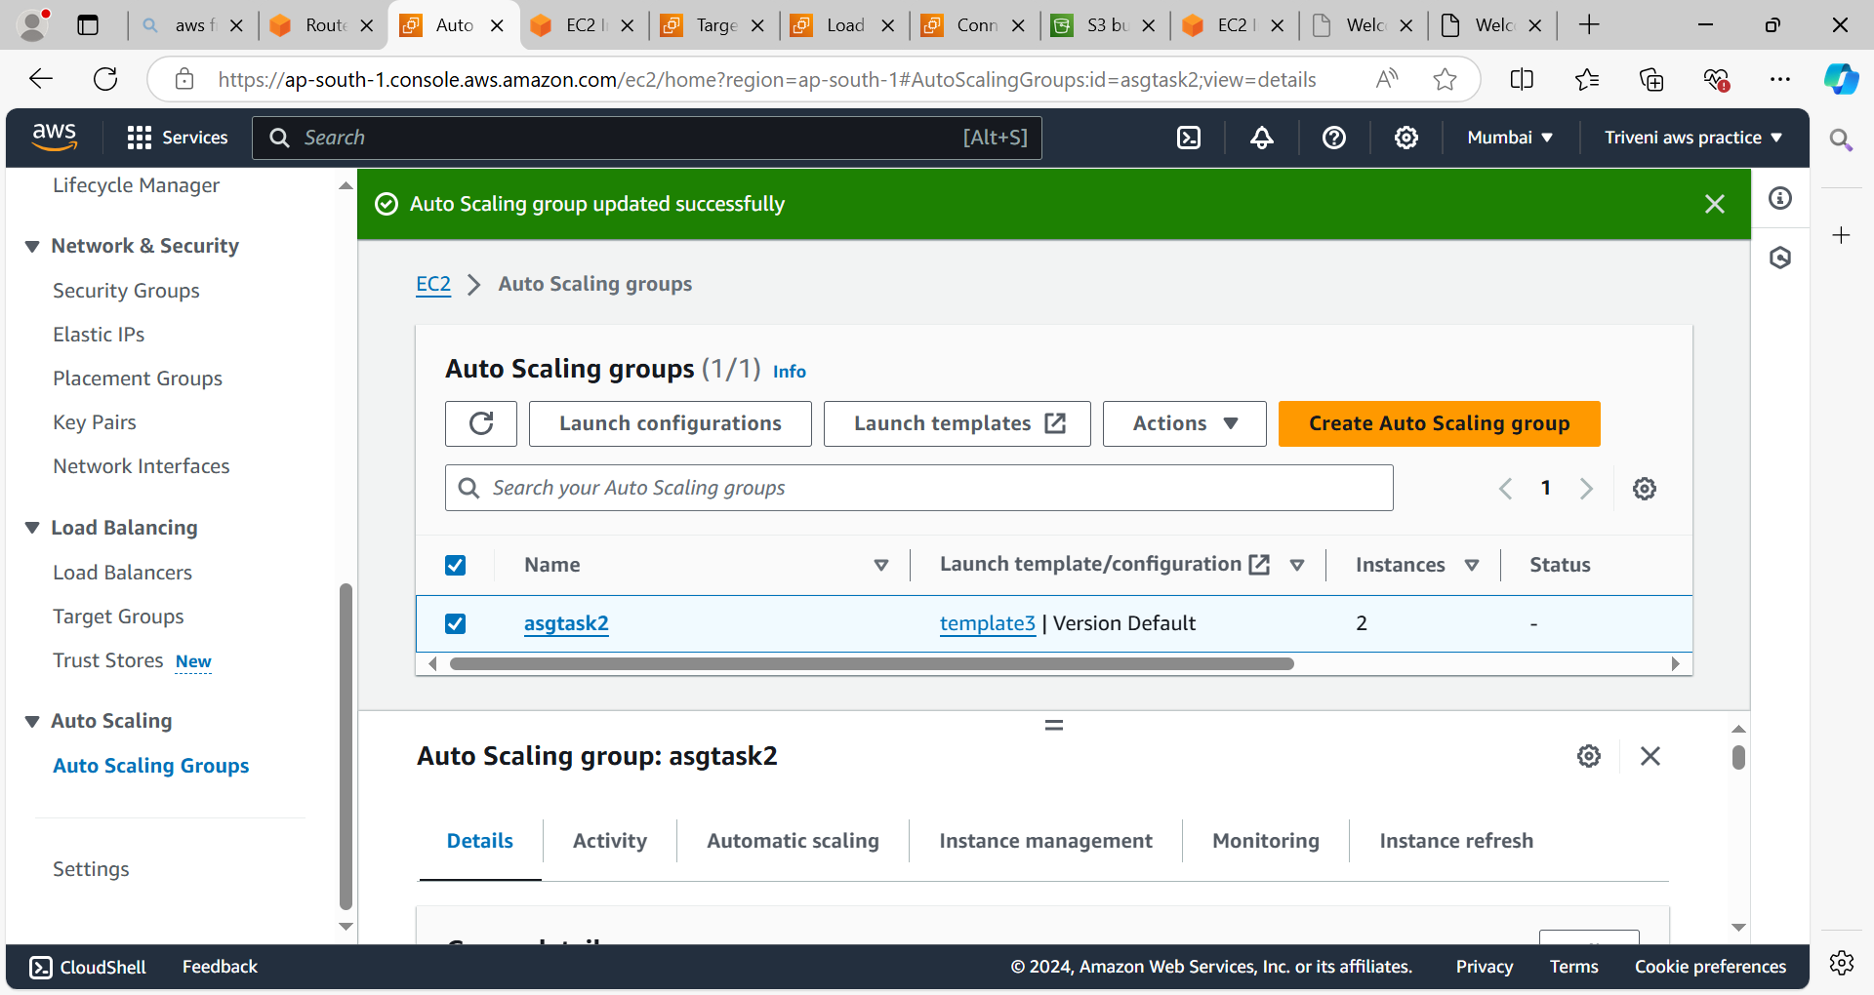

**Bastion host:**

Create the public instance to access the private instance from this.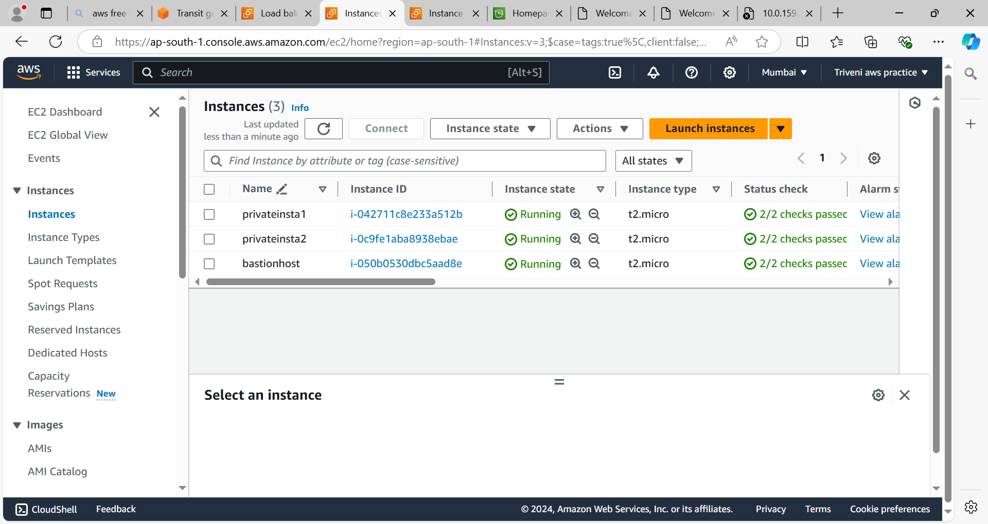

**Load Balancer:**

* Before creating load balancer we need to create target group.
* Create the network load balancer while creating load balancer we need to select public subnets.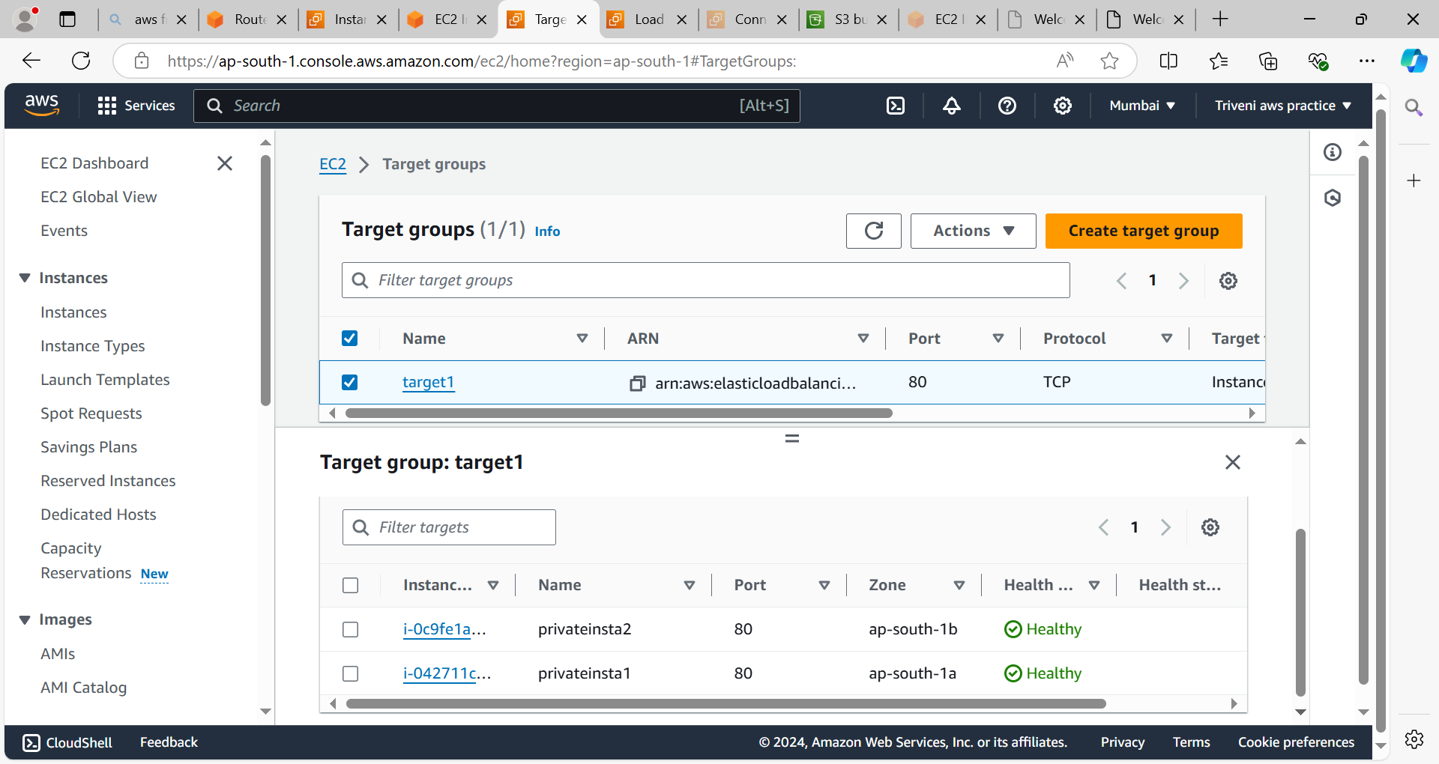

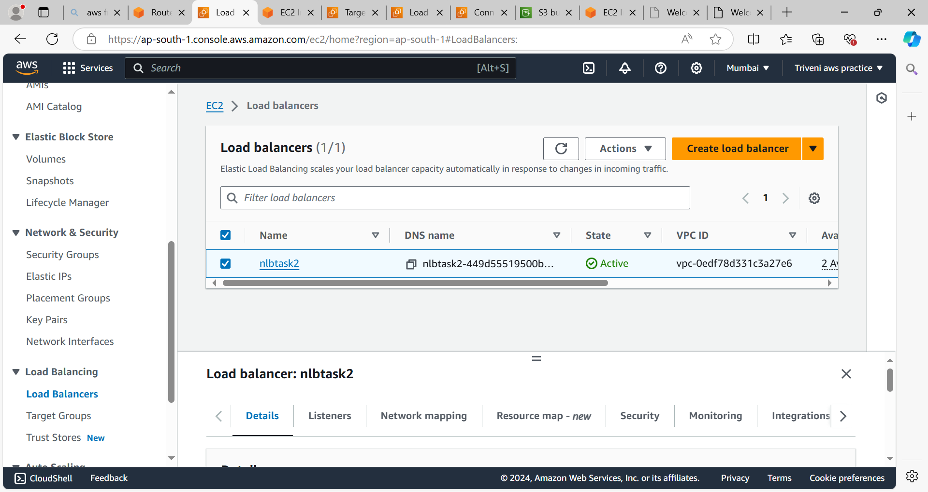

**Transit Gateway:**

* We will create one transit gateway and two transit gateway attachments for two vpc’s.
* After creating transit gateway attachments we need to attach this to the route tables.
* By using transit gateway we can access the resources from one vpc to another vpc.

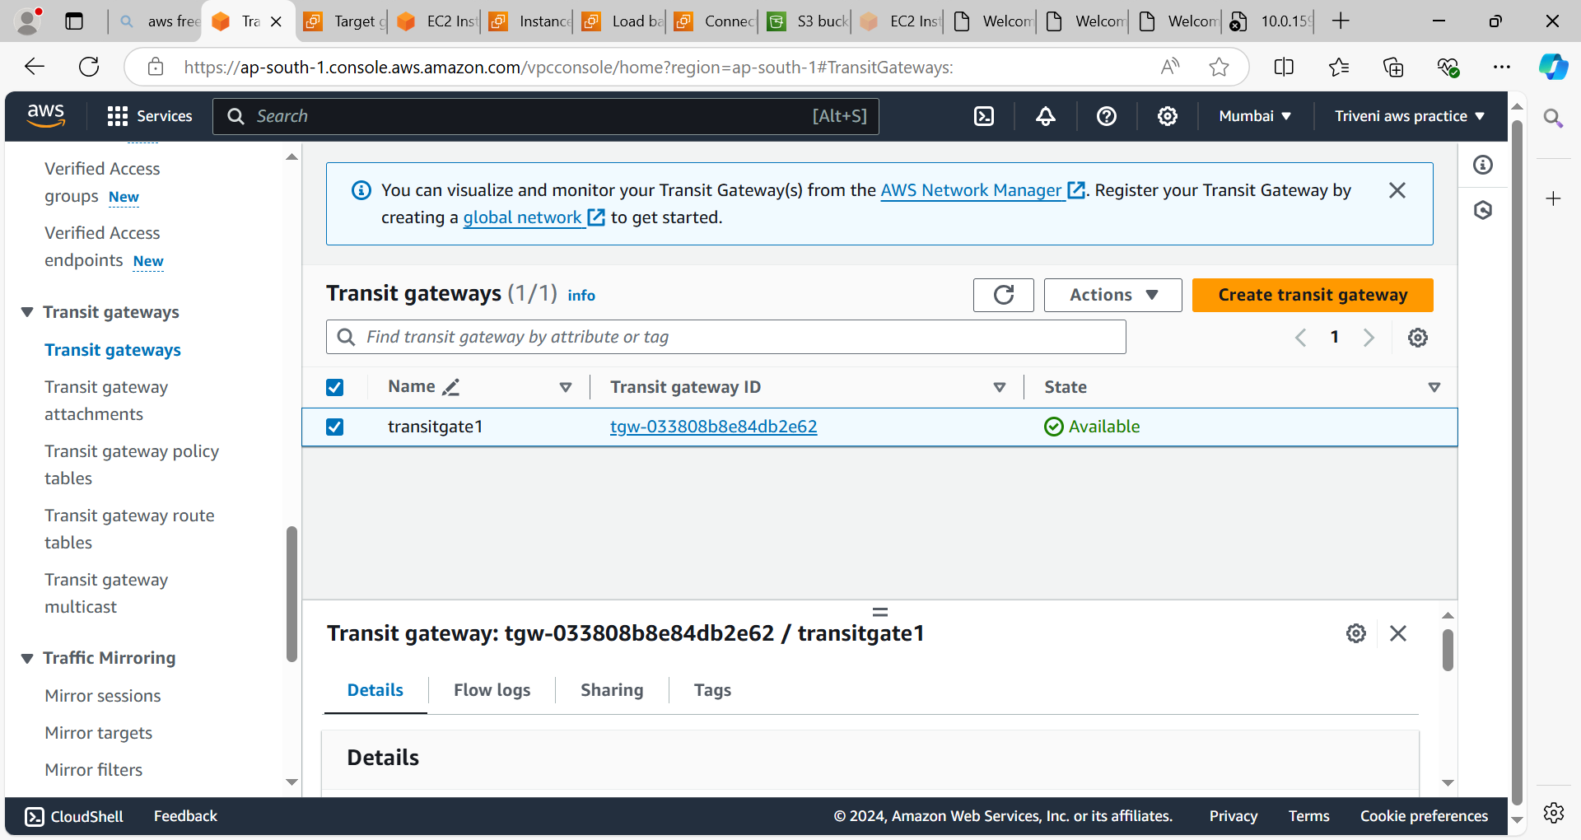

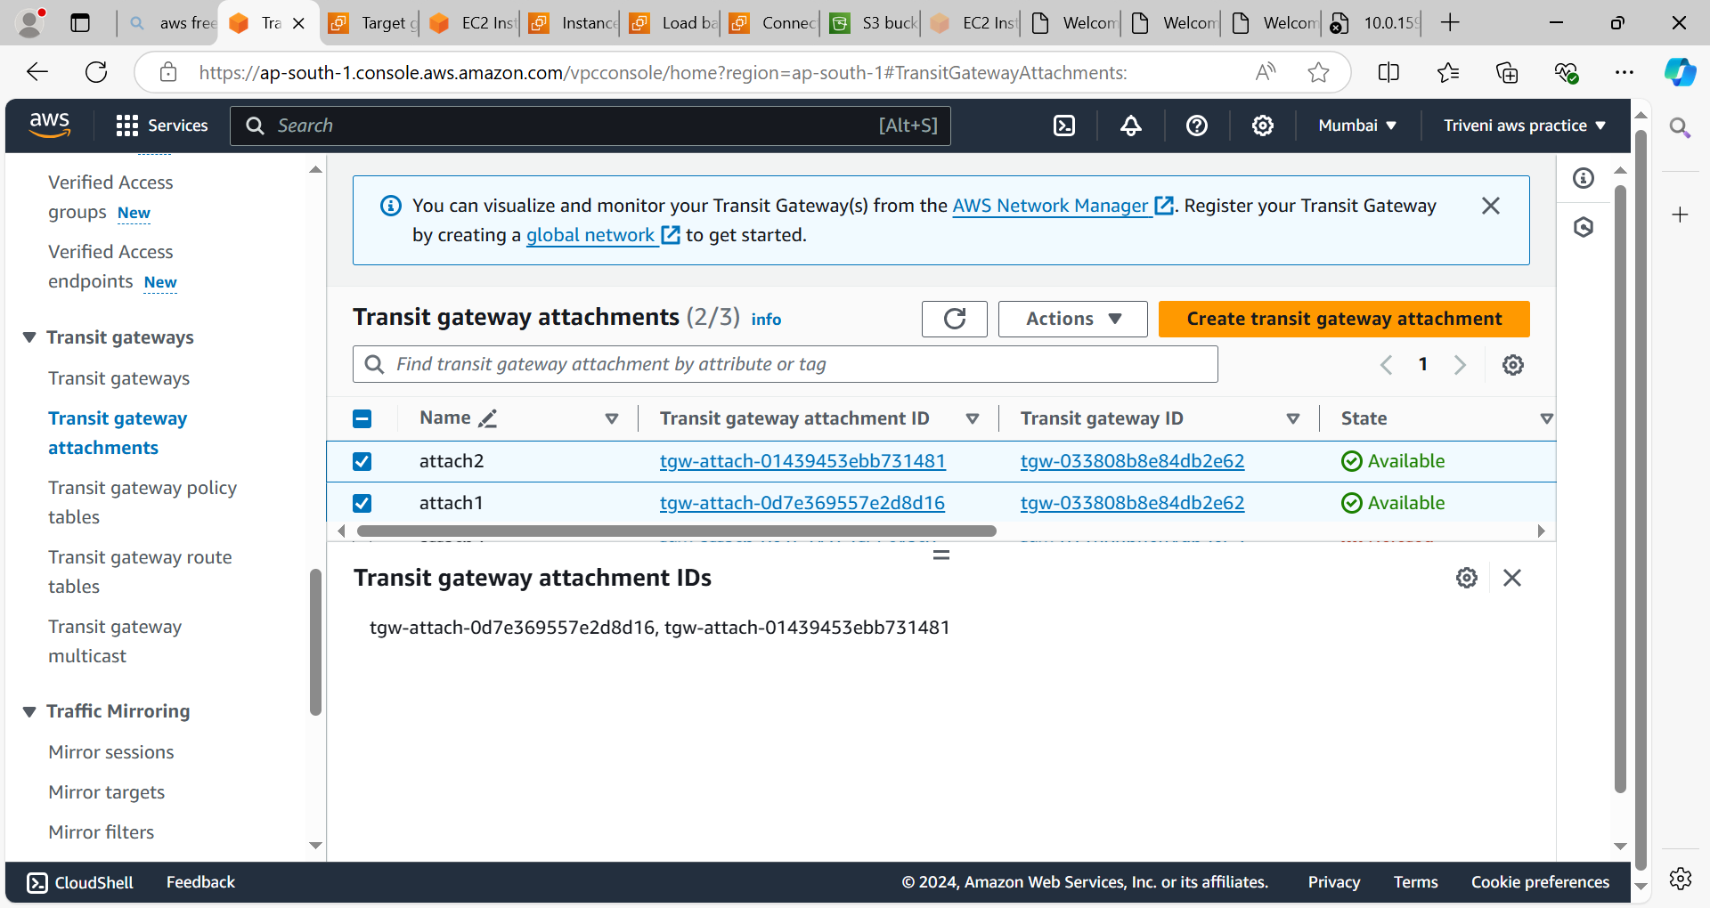

* Connect to the bastion host by using putty.
* From bastion host we can connect to private instance(Private instance is in another vpc by using transit gateway we can connect this instance from bastion host which is in different vpc).
* We can also access the s3 service.

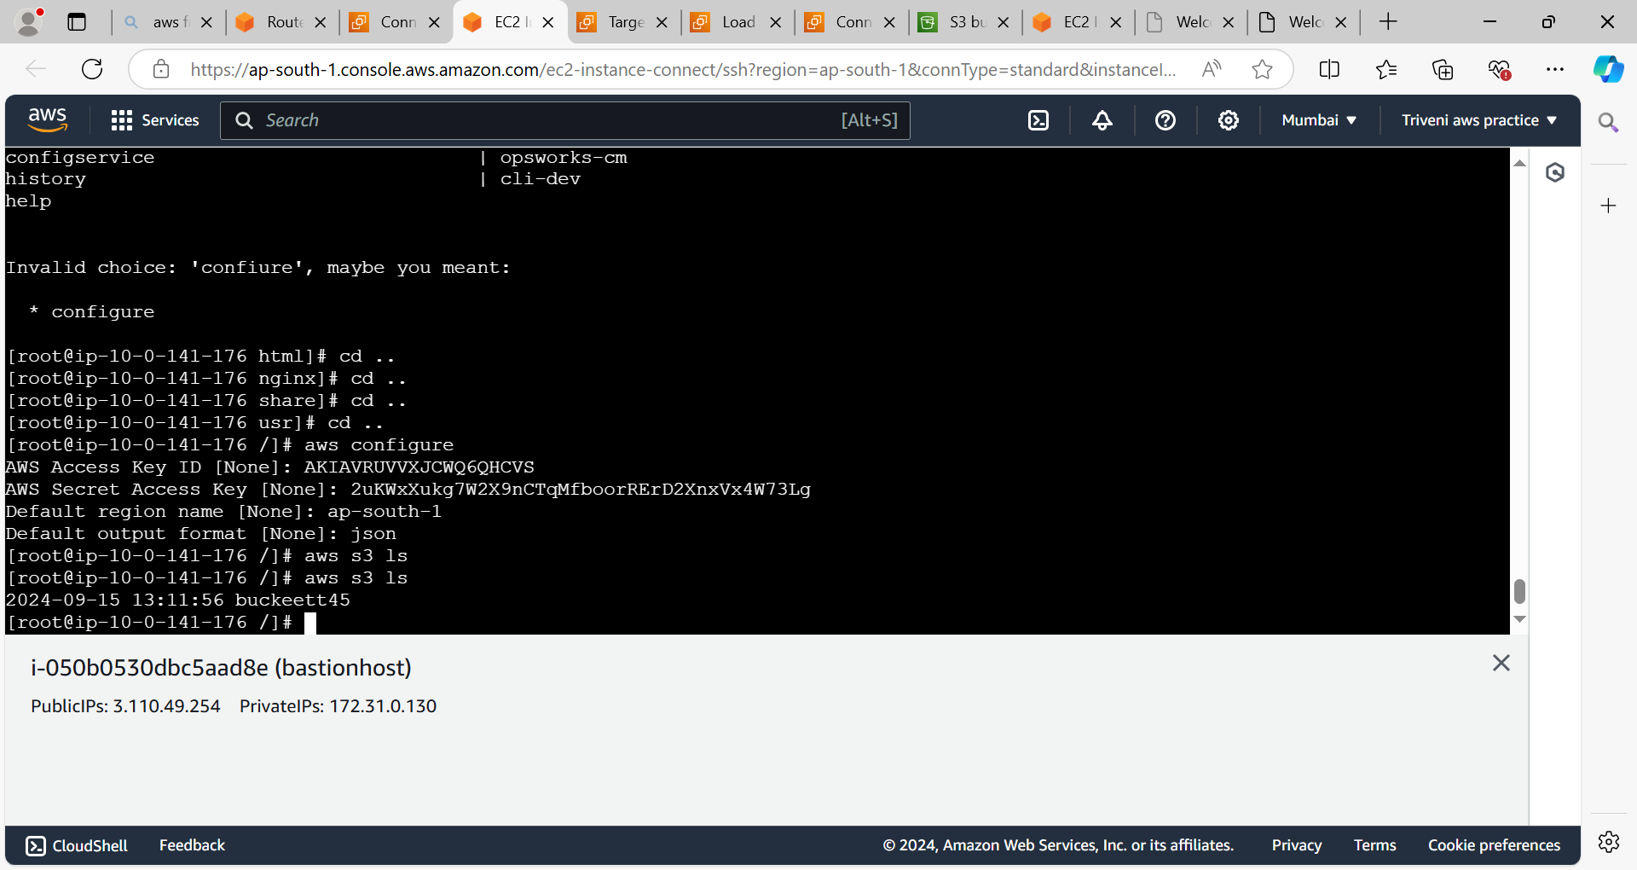

By using nlb DNS name we can access the application which was deployed on private instance.

